**JUnit_Basic Testing Exercises**

**Exercise 3: Assertions in JUnit**

Scenario:

You need to use different assertions in JUnit to validate your test results.

Steps:

1. Write tests using various JUnit assertions.

Solution Code:

public class AssertionsTest {

@Test

public void testAssertions() {

// Assert equals

assertEquals(5, 2 + 3);

// Assert true

assertTrue(5 > 3);

// Assert false

assertFalse(5 < 3);

// Assert null

assertNull(null);

// Assert not null

assertNotNull(new Object());

}

}

**IMPLEMENTATION IN ECLIPSE :**

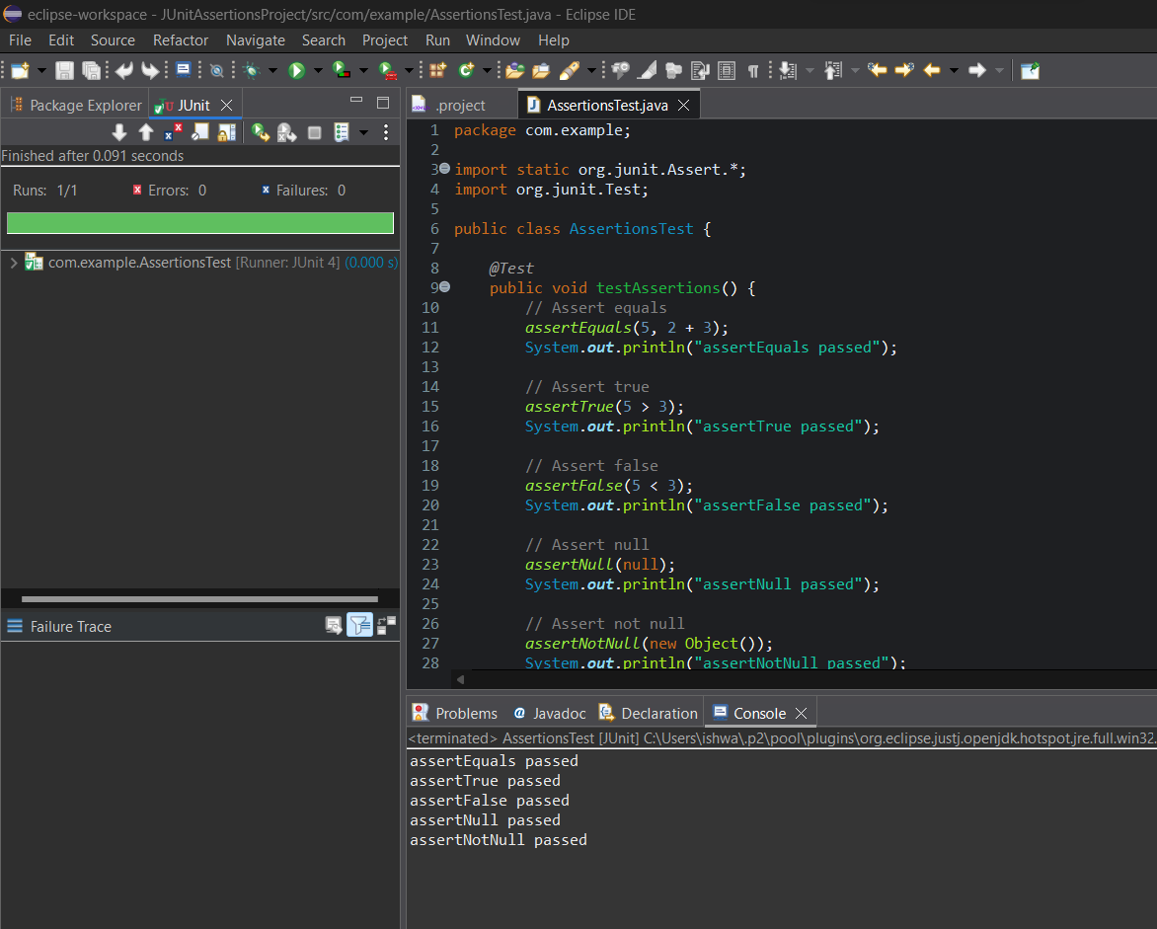

**OUTPUT :**

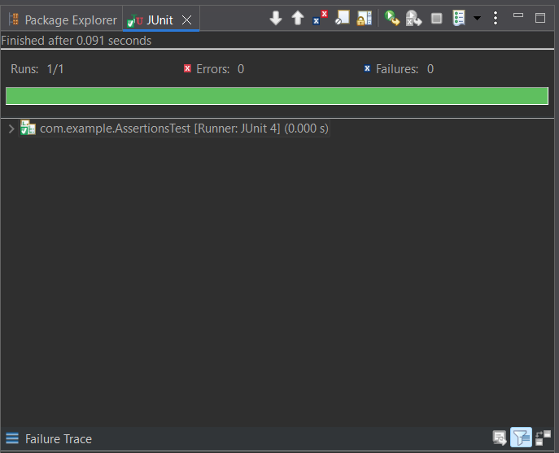

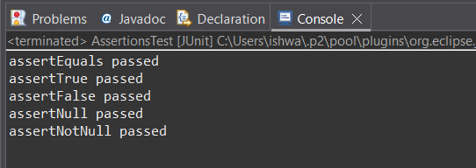

**PROGRAM :**

package com.example;

import static org.junit.Assert.*;

import org.junit.Test;

public class AssertionsTest {

*@Test*

public void testAssertions() {

// Assert equals

*assertEquals*(5, 2 + 3);

System.***out***.println("assertEquals passed");

// Assert true

*assertTrue*(5 > 3);

System.***out***.println("assertTrue passed");

// Assert false

*assertFalse*(5 < 3);

System.***out***.println("assertFalse passed");

// Assert null

*assertNull*(null);

System.***out***.println("assertNull passed");

// Assert not null

*assertNotNull*(new Object());

System.***out***.println("assertNotNull passed");

}

}

**OUTPUT :**



